1. Software Architecture

1.1 System Architecture
The Student Housing App follows a three-tier client-server architecture consisting of a mobile frontend, a REST API backend, and a relational database.

System Flow: STUDENT: Searching and Booking an Apartment
Student searches for an apartment with filters (Frontend)
Request goes to Backend
Backend checks Database (Listings Table: searches for apartments that match the price, location, and availability filters the student selected)
Backend sends matching apartment results back to Frontend
Student selects an apartment and confirms booking → stored in Database (Bookings Table: saves the student ID, listing ID, date of request, and status = Pending)

STUDENT: Using the Chat

Student opens chat and sends a message to a landlord or roommate (Frontend)
Request goes to Backend
Backend checks Database (Messages Table: retrieves the conversation history between the two users)
Backend sends message history back to Frontend
Student sends new message → stored in Database (Messages Table — saves sender ID, receiver ID, message content, and timestamp)

System Flow: LANDLORD: Creating and Managing a Listing

Landlord fills in apartment details and submits a new listing (Frontend)
Request goes to Backend
Backend checks Database (Listings Table: verifies no duplicate listing exists for the same address and landlord)
Backend sends confirmation back to Frontend
Landlord confirms listing submission → stored in Database (Listings Table — saves title, description, price, location, availability date, photos, landlord ID, and status = Pending Review)

System Flow — ADMINISTRATOR: Verifying and Managing the Platform

Administrator opens the pending listings dashboard (Frontend)
Request goes to Backend
Backend checks Database (Listings Table: fetches all listings where status = Pending Review, and Reports Table: fetches all unresolved user reports)
Backend sends pending listings and reports back to Frontend
Administrator approves or rejects a listing → stored in Database (Listings Table: status updated to Verified or Rejected, and Landlord is notified)

Component Diagram (UML)
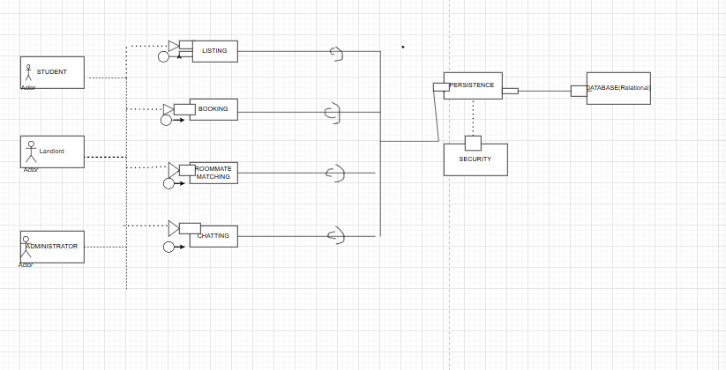

2. Detailed Design
Class Diagram
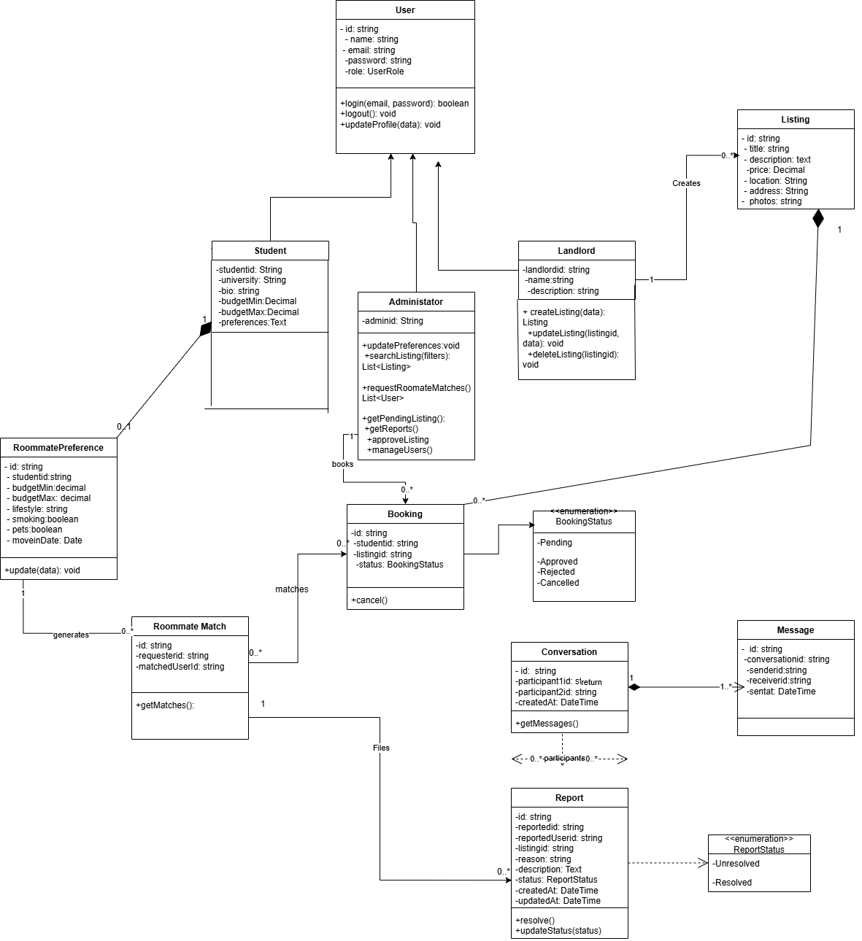

Sequence Diagram
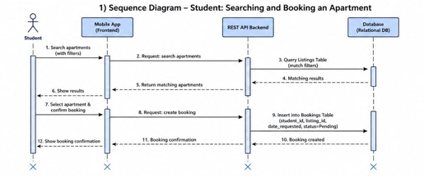
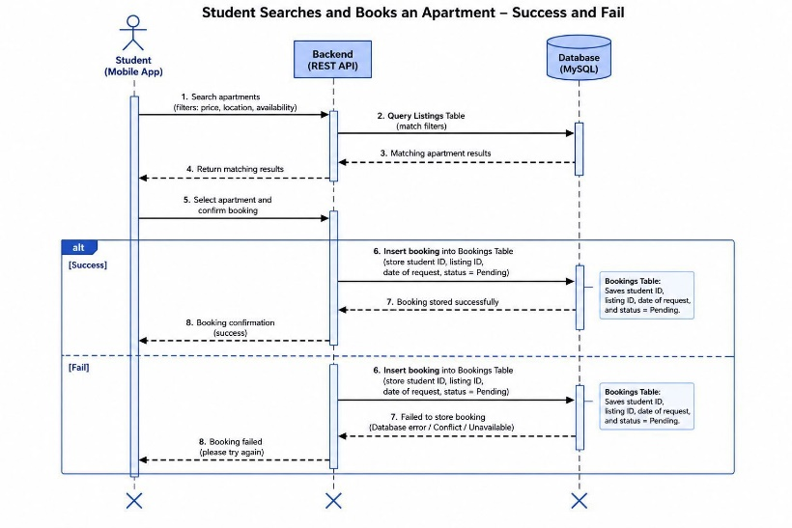
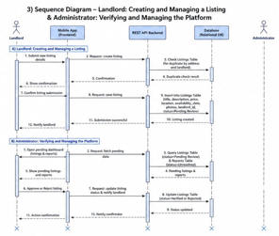

3. Modeling
Use Case Diagram

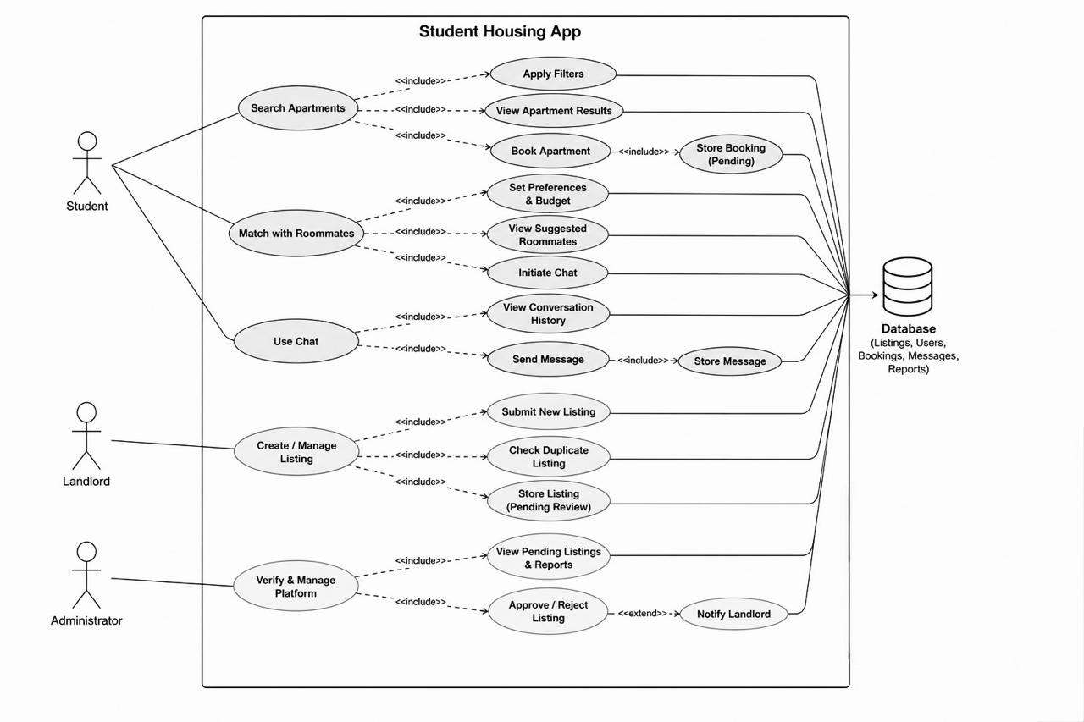

Activity Diagram
Activity Diagram No.1: Searching and Booking an Apartment

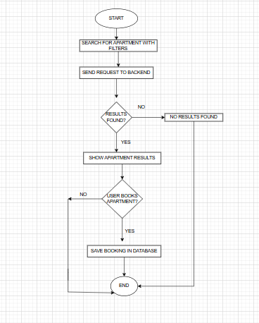
Activity Diagram No.2: Managing Listing
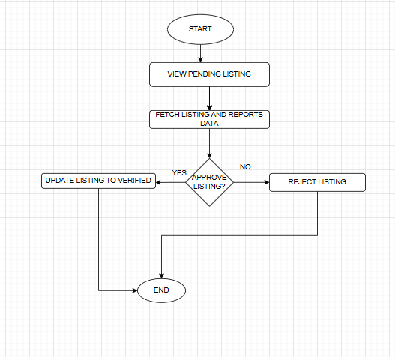
State Diagram
Apartment Booking State Diagram
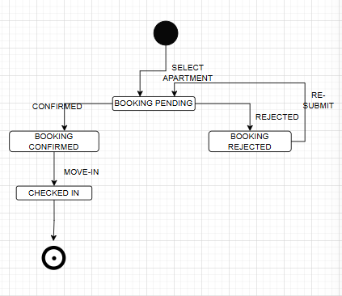

Roommate Matching State Diagram
